Account -> switch to Task manager
Task manager
In navbar respective admin can see
- Quiz
- Quiz group
- Tournament- for global

Create quiz
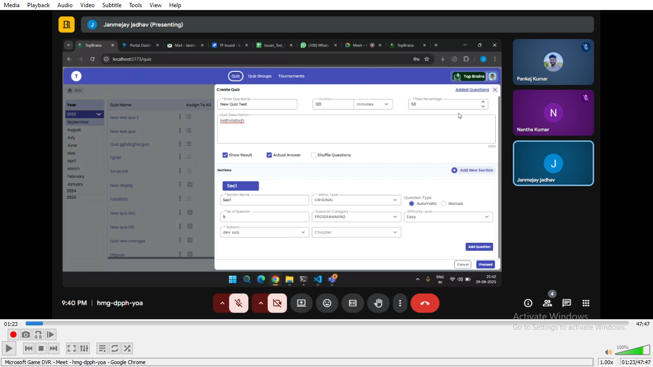

After clicking on create button -> will get popup like do you want to create form to capture additional detail

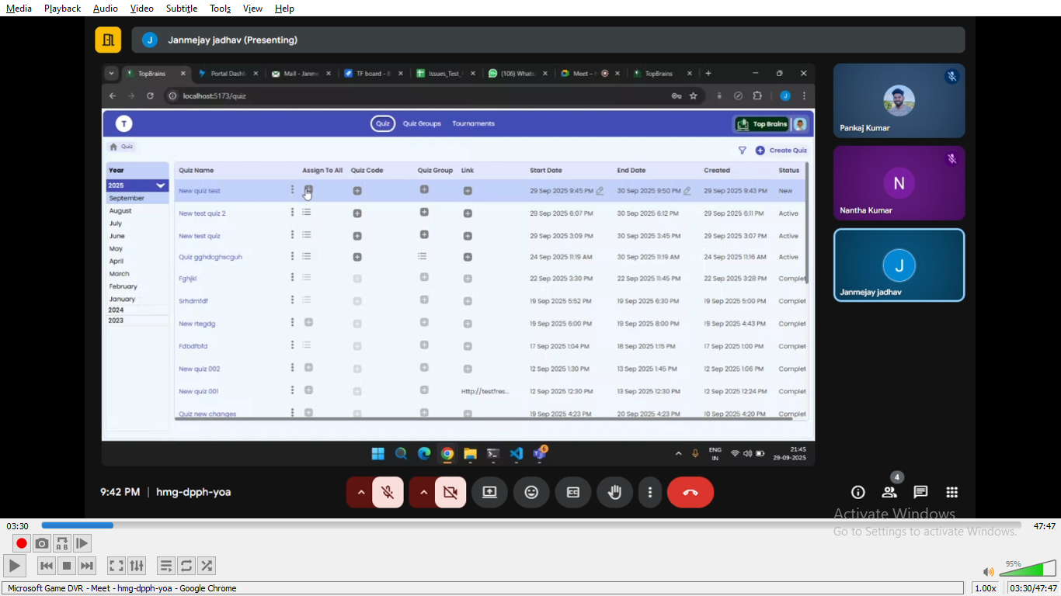

The several option
- Assign to all- click on it ->select the respective organization->click on create
- Quiz code->same for all
- Quiz group
- Link

Login using student
Need to register in organization fisrt +register with the help of
If already created like already listed below 2
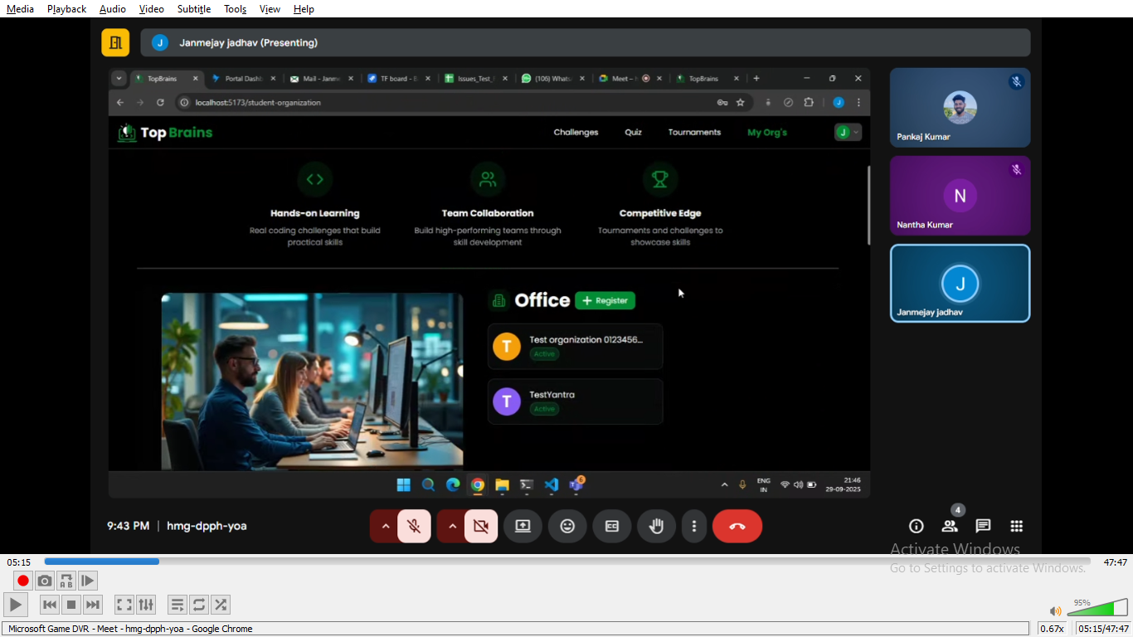

-> directlly click on that to navigate

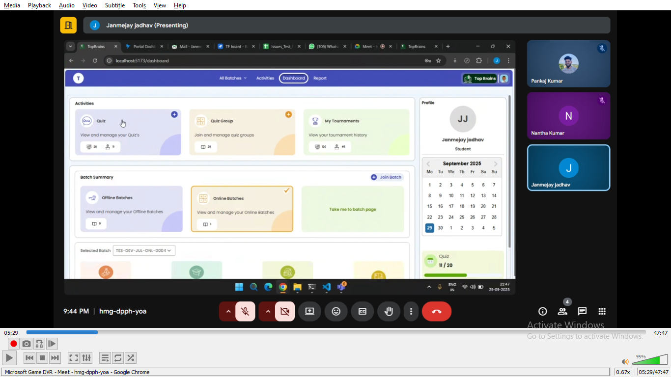
Click on 1st card quiz

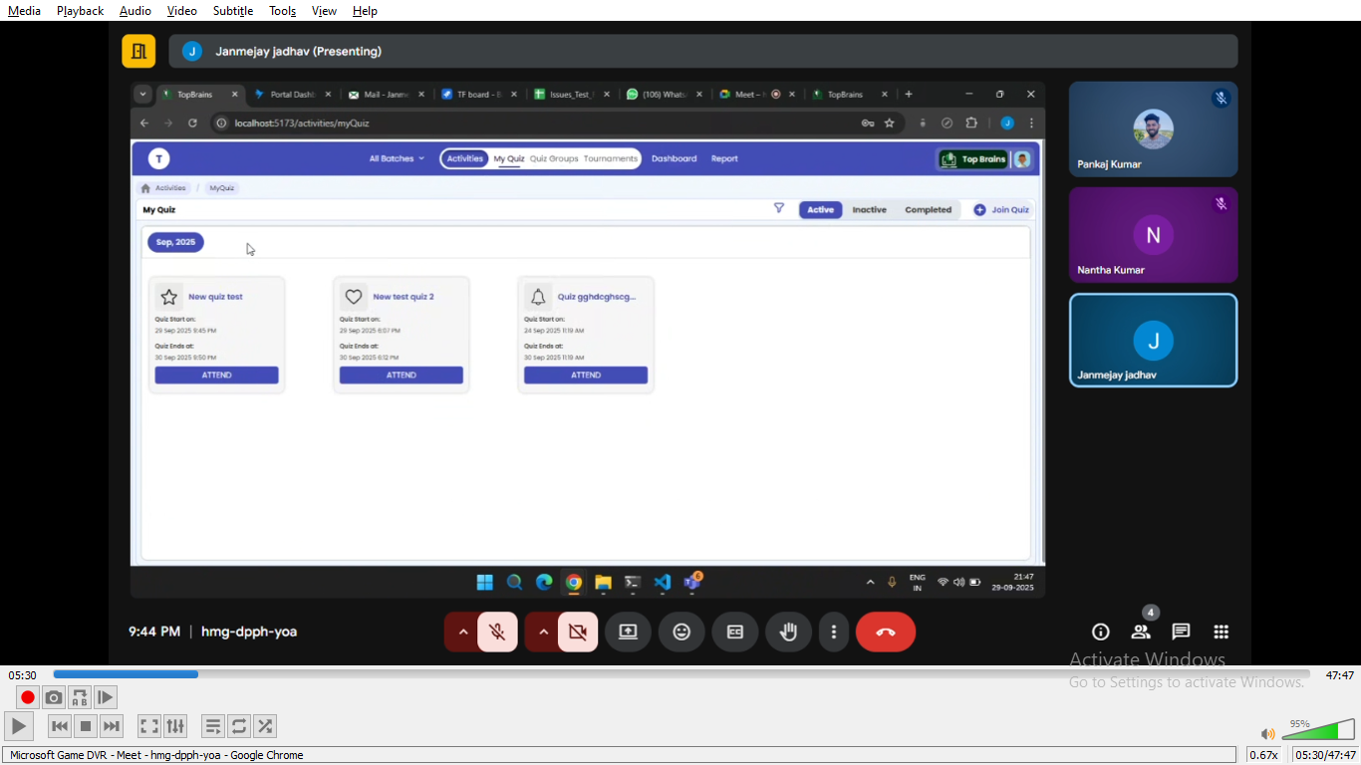
On top right corner we will click on join quiz->paste the code ->join
After that he can click attend on respective quiz card

